

**Green University of Bangladesh**

**Department of Computer Science and Engineering (CSE)**

**Faculty of Sciences and Engineering**

**Semester: (Fall, Year:2024), B.Sc. in CSE (Day)**

**LAB REPORT NO #05**

**Course Title: Integrated Design Project 1**

**Course Code:  CSE 324**

**Section:213 D7**

**Lab Experiment Name: Advanced Vehicle Tracking System: Data Flow Diagram.**

**Student Detail**

|  |  |  |
| --- | --- | --- |
| **Name** | | **ID** |
| **1.** | Md. Rajuan Hossen | 221002100 |
| **2.** | Hasebul Hasan | 221002104 |

**Lab Date : 18/07/2024**

**Submission Date : 20/07/2024**

**Course Teacher’s Name : Md. Romzan Alom**

**[For Teachers use only: Don’t Write Anything inside this box]**

|  |
| --- |
| **Lab Report Status**  **Marks: …………………………………                              Signature:.....................**  **Comments:..............................................                              Date:..............................** |

**Introduction**

A Data Flow Diagram (DFD) is a graphical representation of data movement within a system. It highlights how inputs are transformed into outputs through processes, data stores, and external entities. In this lab, we created DFDs for our Advanced AI-driven Vehicle Tracking System (AVTS) to visualize the data interactions and ensure the system's functionality aligns with its requirements.

**Components of a Data Flow Diagram**

1. **Processes**: Represent actions performed on the data (e.g., "Track Vehicle" or "Calculate Fare").
2. **Data Flows**: Arrows indicating the movement of data between components.
3. **Data Stores**: Represent where data is stored (e.g., databases).
4. **External Entities**: Represent sources or destinations of data outside the system (e.g., "Customer" or "Admin").

**Level 0 DFD: Context Diagram**

The Level 0 DFD provides a high-level overview of the AVTS, showing all external entities interacting with the system and the primary process of managing vehicle tracking services.

**Level 1 DFD: Main System Components**

The Level 1 DFD expands the primary process into sub-processes such as "Vehicle Tracking," "Fare Calculation," and "Service Monitoring." It illustrates the detailed data interactions within the system.

**Level 2 DFD: Detailed Sub-Processes**

The Level 2 DFD delves deeper into specific sub-processes like "Track Vehicle," showing detailed tasks such as real-time GPS data retrieval, bus capacity monitoring, and distance notification services.

**Figures**

1. **Figure 1**: Level 0 DFD

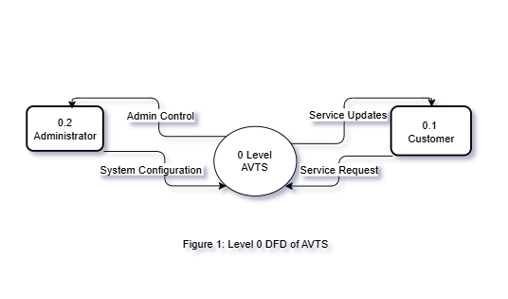

1. **Figure 2**: Level 1 DFD

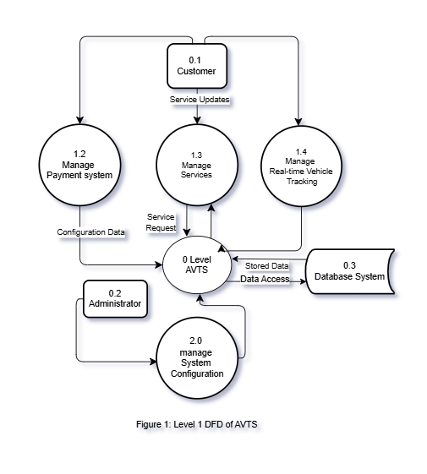

1. **Figure 3**: Level 2 DFD

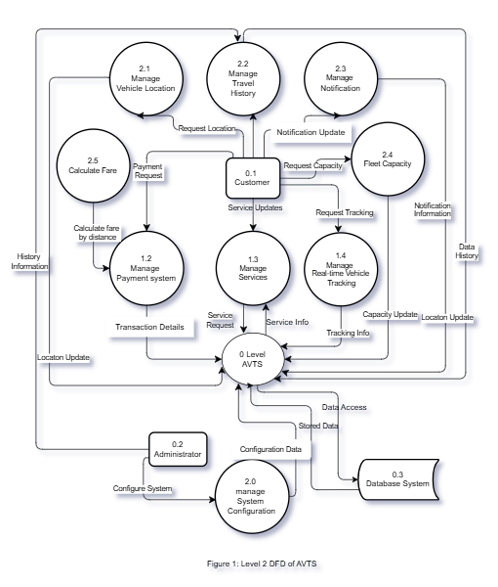

**Discussion**

While creating the DFDs, the main challenge was ensuring every component of the AVTS was accurately represented without overcomplicating the diagrams and balancing detail with clarity required iterative refinement and feedback. The structured approach of moving from Level 0 to Level 2 helped address data flow and system logic gaps.